Don’t Panic!

This challenge says:

Find the flag on Sekrit Skwerl's Under Construction page.  
  
Step 1. Find the page that is "Under Construction"  
Step 2. View the "page source"  
Step 3. Find the flag!

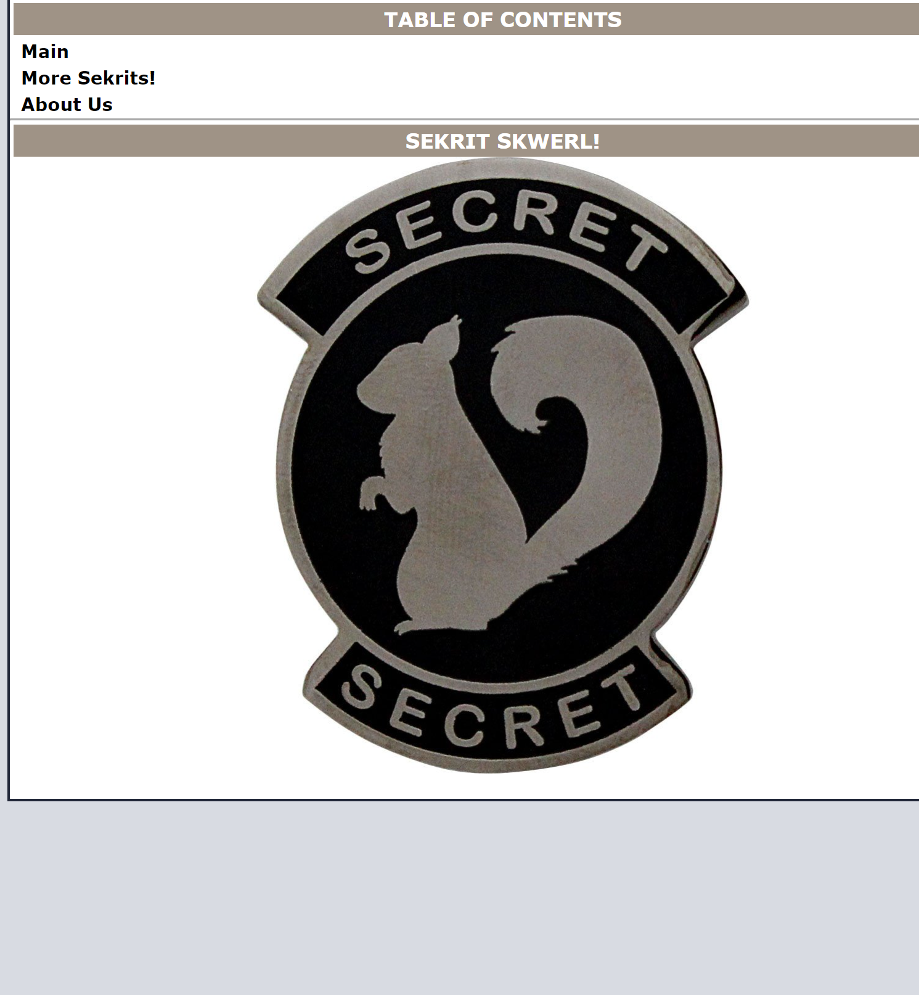

We get a webpage like this, the instructions say to navigate to the webpage that says under construction, so we look through and find that in the About us page, there we right click and inspect to find the flag in the html: 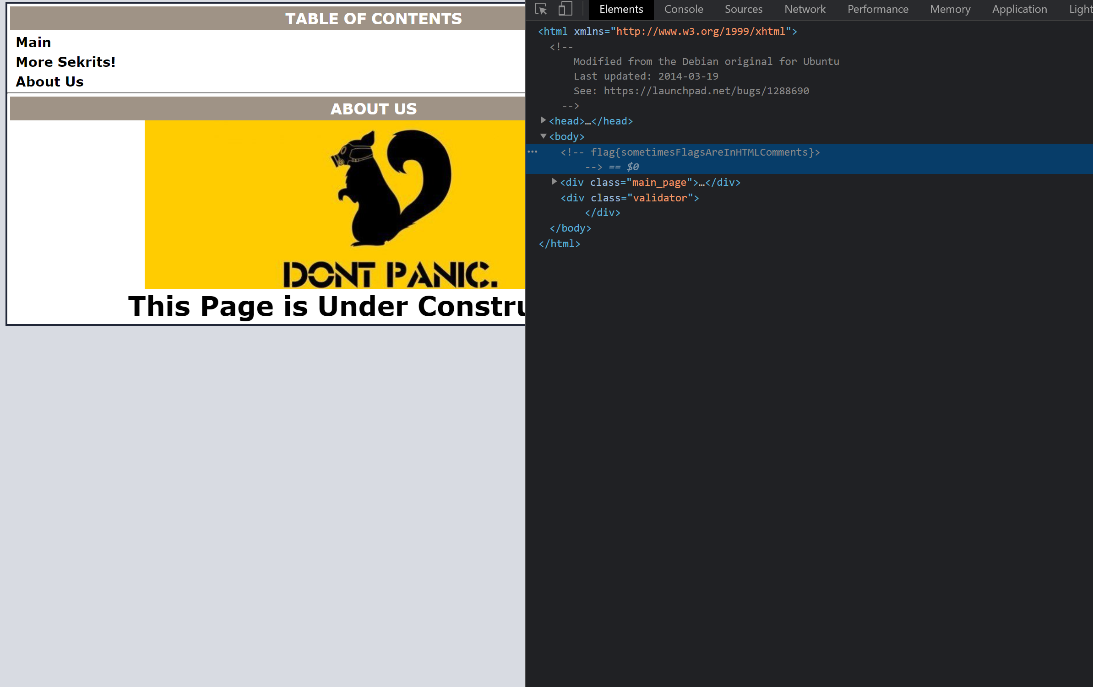

HTTP 1

This Challenge says: This HTTP method requests information from a server

If you don’t know the answer to this you can look it up, but basically the answer is GET. GET is used by HTTP to request information from the server (if GET is being used you can often find variables in the url for ex: [www.example.com/?var=thisisavariable](http://www.example.com/?var=thisisavariable))

Nemisis

This challenge says: What is the secret message hidden near the "close body" tag on Secret Squirrel's website? 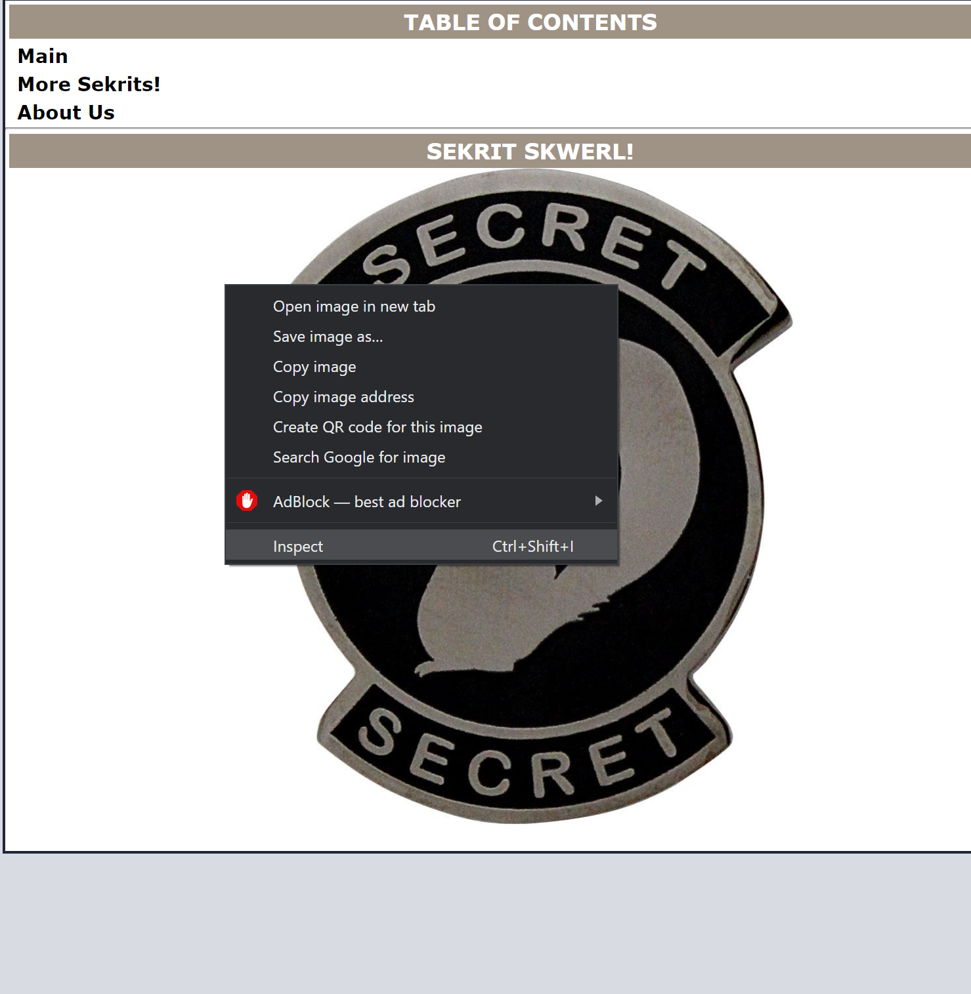

We get a webpage that looks like this, the challenge instructions say to view the source code so right click anywhere on the page and select inspect

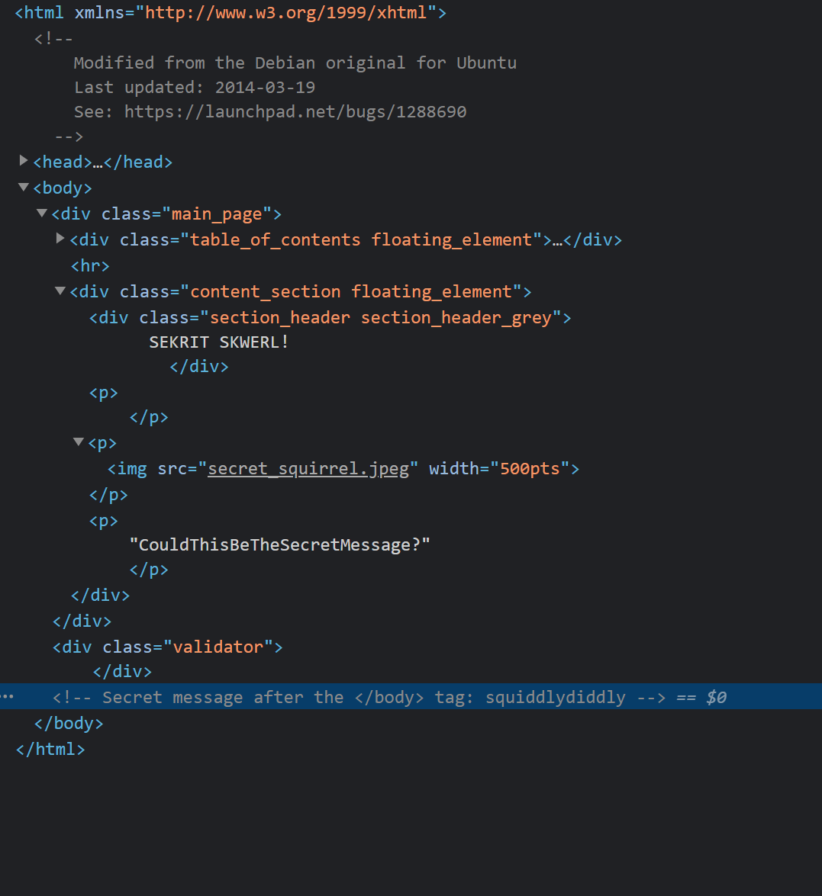

After inspecting the page we see^

There is a comment with the secret message in it, this is the flag

Certificates

This challenge says: What is Google's Certificate Authority KeyID?

A Certificate Authority Key ID is something that we can find in the page information of a website so for this challenge we first navigate to [www.google.com](http://www.google.com), once there we go to the icon next to the url and click on it

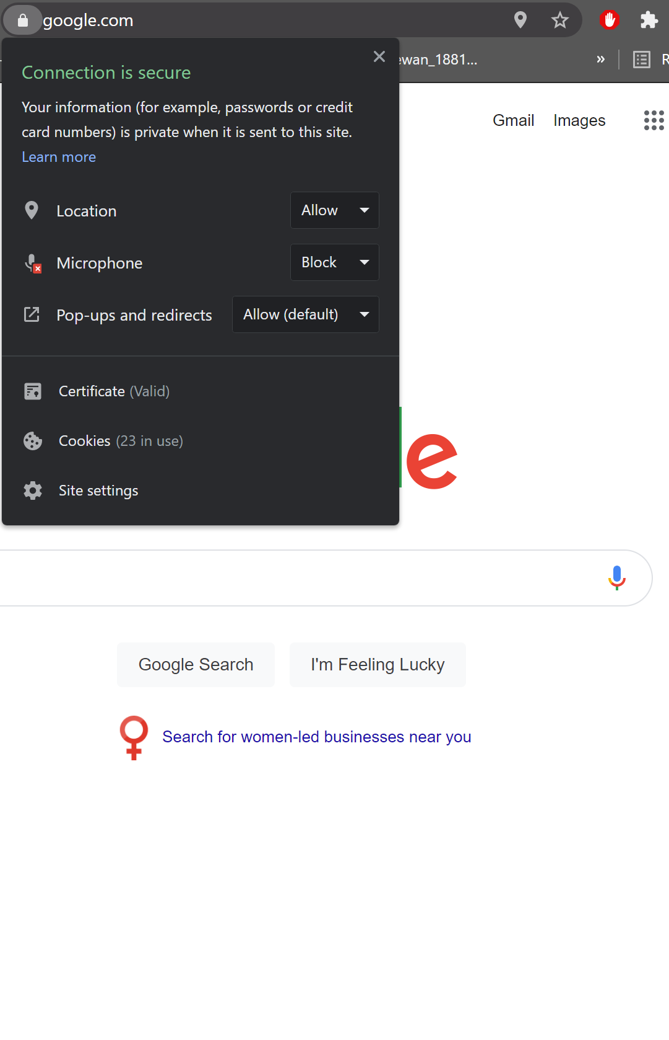

From here if we click on Certificate we will see information regarding the certificates of this webpage, and here under the Details tab we can scroll down and find a certificate called: Authority key. If we click on it we can view the ID of this key

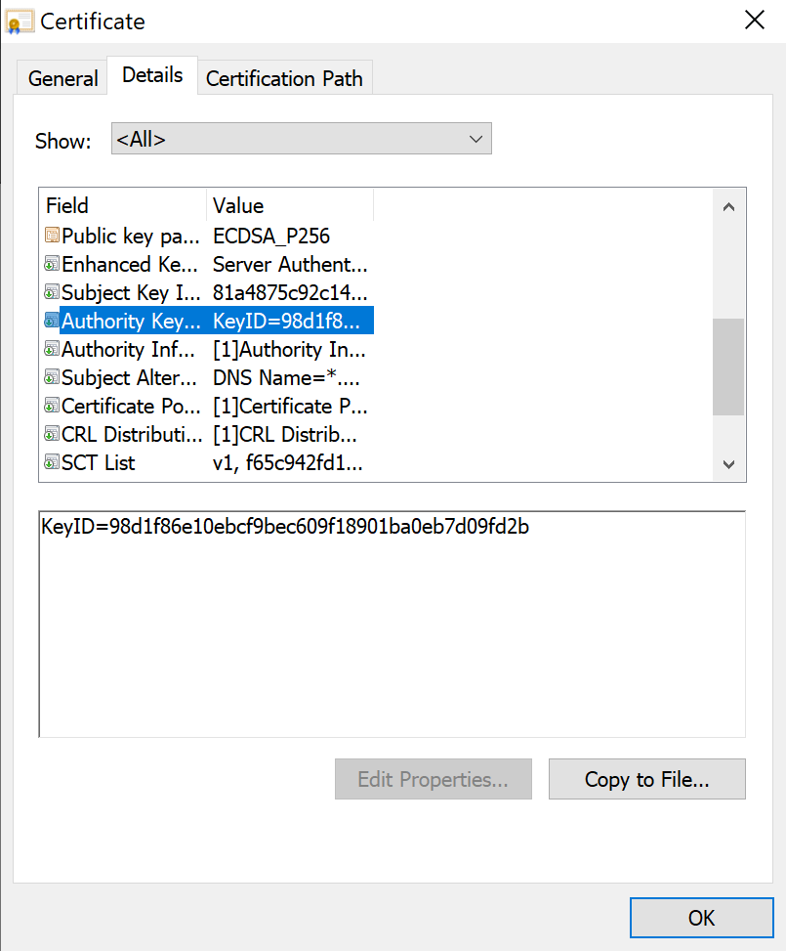

Harvest Skwerl

This challenge says: Our old friend Sekrit Skwerl is taking a much needed vacation and posted some photos!

For this challenge we’re given a webpage that looks like this: 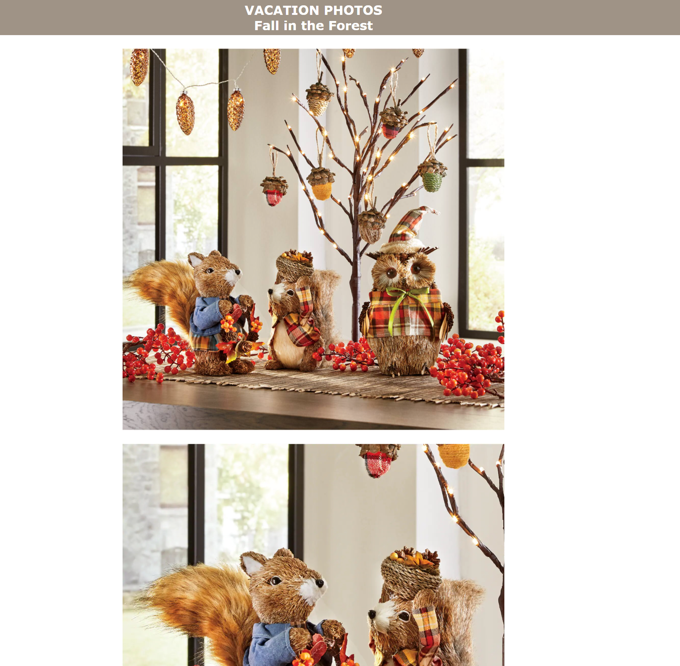

Personally, this was the hardest web challenge. After looking through it one last time I noticed that when you look at the images in the Sources tab when you inspect the page, you can see the file size of all of these pictures. I noticed that one of the pictures (the one called “me-and-missus.jpg”) was 1.4 Mb in size, which is very large when compared to the other files which were only in the couple hundred Kb range. This proved to me that there must be hidden data inside this specific image (me-and-missus.jpg is the second picture shown on the webpage snippet above). I opened up my kali VM and tried out different commands to get data from images(<https://infosecwriteups.com/beginners-ctf-guide-finding-hidden-data-in-images-e3be9e34ae0d> is an amazing resource for basic Kali commands for this type of thing). Finally I tried the command string me-and-missus.jpg (this command displays all 4 or more character strings in the data of a file) and looking through the output I found the flag.

Hidden in Plain Sight?

This challenge says nothing but the url for the website we need to check out, the website we get is:

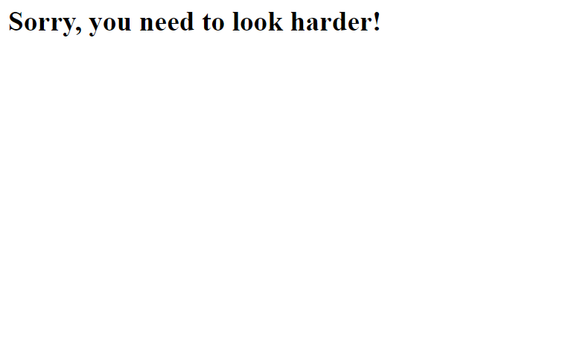

After a quick inspect of the website I find in the html: 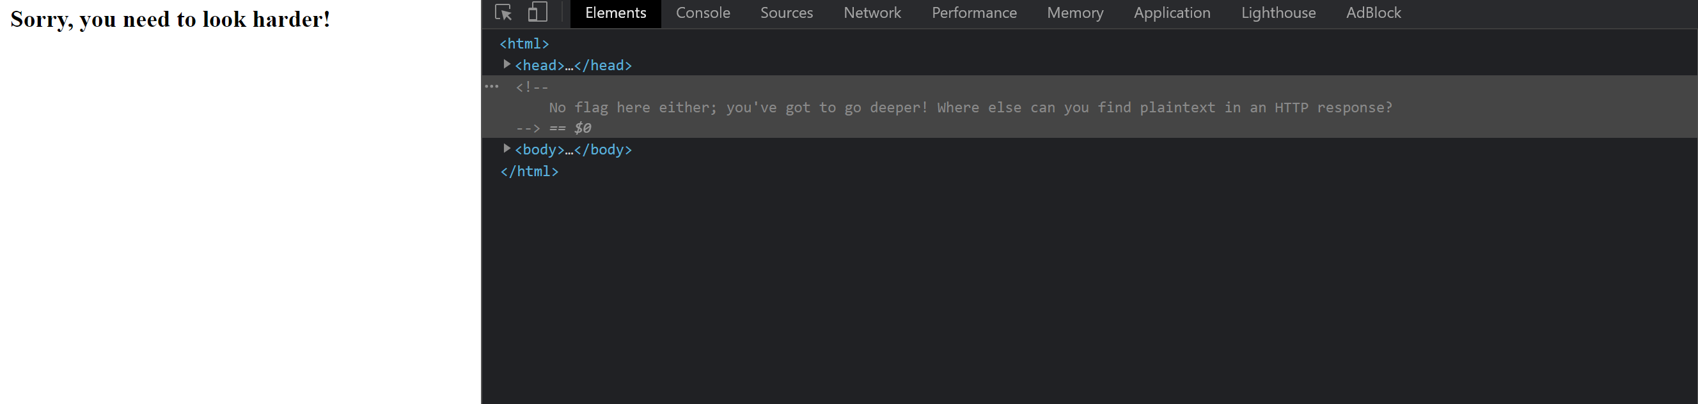

After seeing this comment I thought of the previous challenge “HTTP 1” and went to check out the Network tab 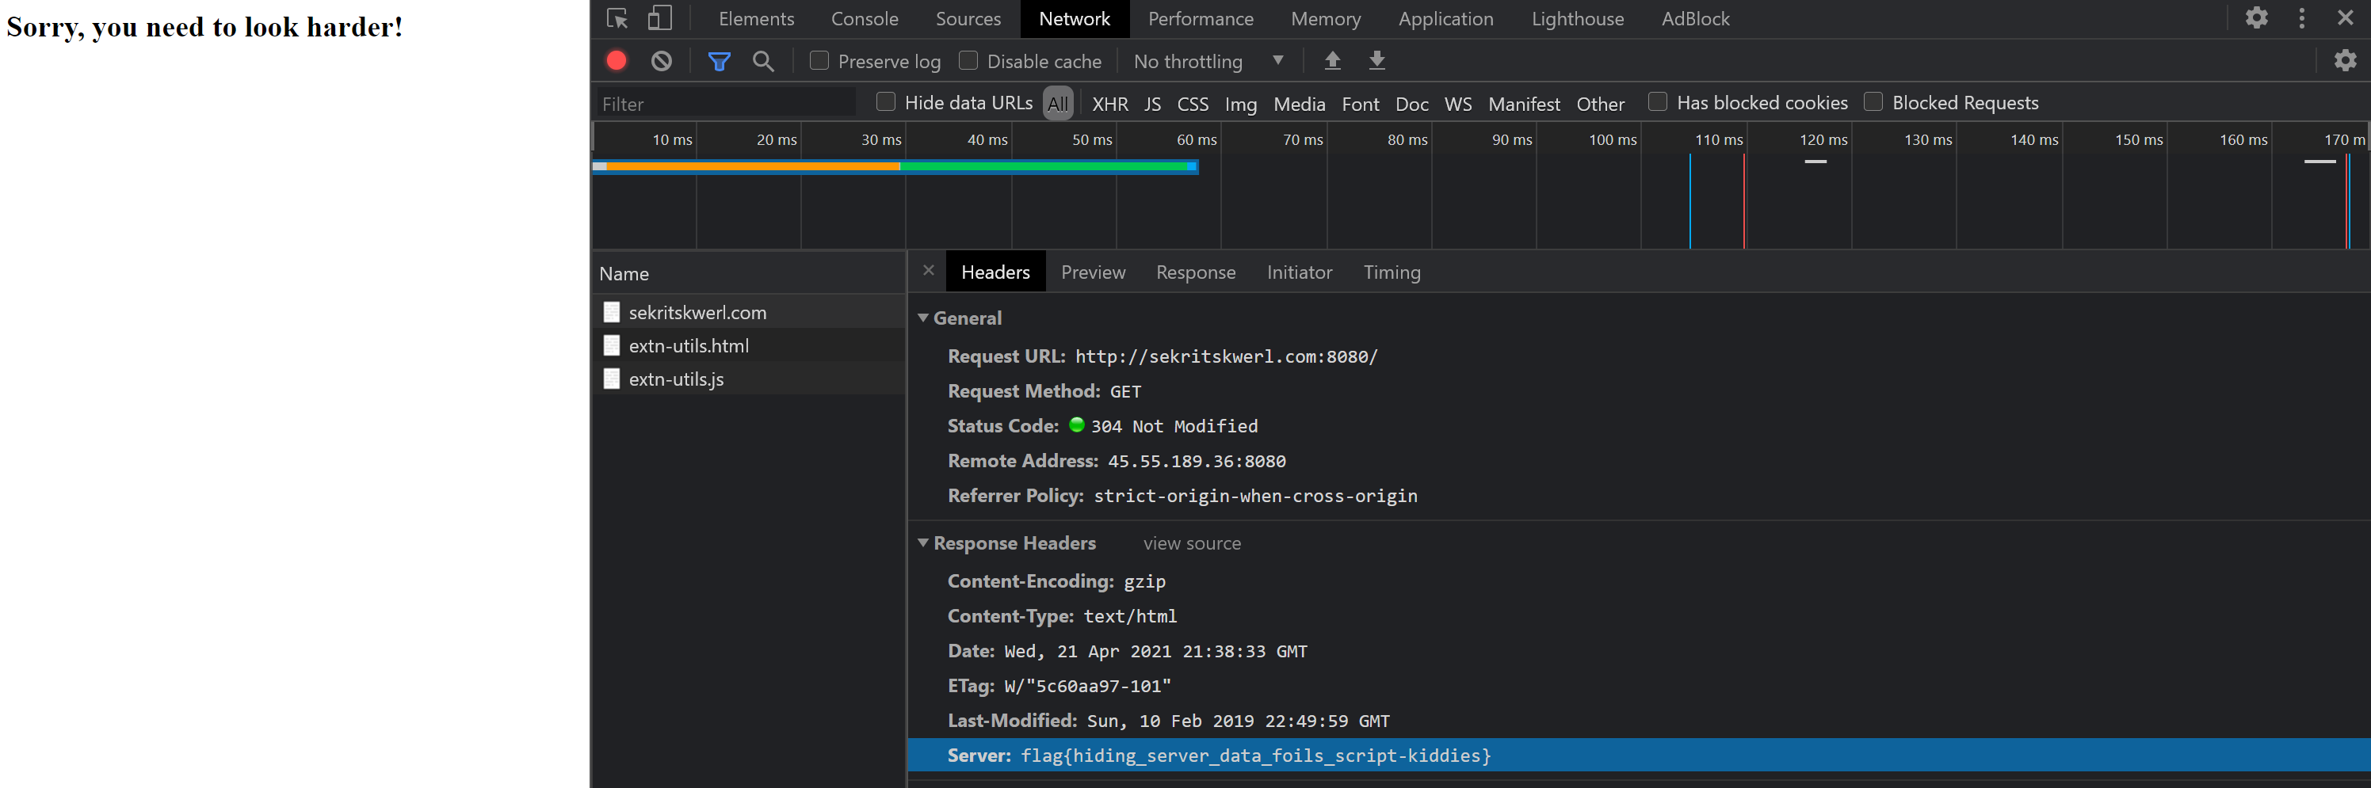

Here under the Headers tab and in the Response Headers column we see the server’s response to a GET request that was made, and we find the flag